1.1.2 Area of Rectangle :

A) Algorithm
1. Start
2. Read length (L) and width (W)
3. Compute area = L × W
4. Display the area formatted to 2 decimal places
5. Stop

B) Flowchart
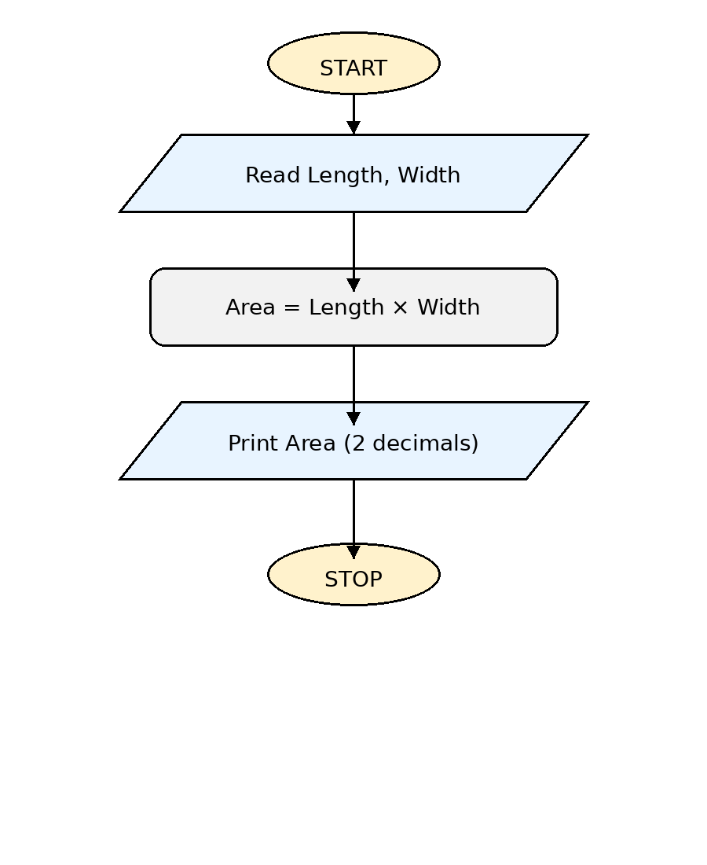

C) Python Code
length = float(input())
width = float(input())
area = length * width
print(f"{area:.2f}")
